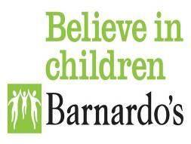

Boloh Helpline
Emergency Covid Appeal

Section A: Referral made by

Name of person making the referral:
Telephone number of person making the referral:

Email address of person making the referral:

Section B: Child/young person’s details

Details of the Child (who is the subject of the application)
Adult and Child/ young person details (name, DOB, address, telephone)

Confirm consent obtained for Helpline to contact service user | Yes / No

Application details
What is the reason for the application to the Fund?

What attempts have been made to obtain funds from other sources (eg Section17 payments) to support the identified need?

What do you want funds for?

How much do you want from the fund to support the child/young person named?  Please itemise requests (e.g. laptop £299) | Total £

